|  |
| --- |
| **Queensland University Technology** |
| MAB681 Visualization Project Proposal |
| **3D Diffusion Tensor Field Visualizations of the Human Brain** |
| C:\Documents and Settings\Timothy Ka Lok Fan\Desktop\coronal_slice.jpg |
|  |
|  |
|  |
|  |

****

**Christopher Savini n5741467**

**Timothy Fan n5122414**

**Timothy Morris n5671043**

**Date: 21st August, 2009**

# Summary

In the past, imaging the brain has been restricted to post-mortem studies. MRI scans have made it possible for researchers to study the structure of the brain in a living patient.

Our objective is to take the data from a diffusion MRI scan and produce some visualisations using tensor information to highlight neural pathways in the brain. These visualisations will be useful for learning about the structure of the brain, specifically the Tractographic reconstruction of neural connections.

Visualizing neural pathways can be used to measure changes in white matter, for example during aging. One of the most important initial applications in the visualising of neural pathways is the localization of tumors in relation to the white matter tracts (such as path deflections around a tumor). It is also possible to use these types of visualizations in the surgical planning for some types of brain tumors; surgery is aided by knowing the proximity and relative position of the corticospinal tract and a tumor.

The use of DTI for the assessment of white matter in development, pathology and degeneration has been the focus of over 2,500 research publications since 2005. It promises to be very helpful in distinguishing Alzheimer's disease from other types of dementia [1].

The data source we have chosen to analyse is a tensor field in DTI (diffusion tensor image) format.

# Project Description

* 1. **Data Format**

The data is comprised of two parts, firstly a 3D regular grid where each point contains an image intensity value that reflects the single best measurement of the rate of water diffusion at that location. The second portion of data, each voxel has an associated 3 x 3 tensor matrix representing the diffusivity of water in each direction from the point.



* 1. **Visualisation Techniques**

***Elipsoid Tensor Glyphs***

The diffusion tensor of water in three dimensional space can be represented by Ellipsoid Glyphs. These Glyphs have dimensions proportional to the associated diffusion vector. This technique can be used in fiber tracking as glyphs elongated in a collective direction can show the ‘flow’ of neural connections.



***Principal Component Analysis***

Each voxel is assigned the extremer values of surface curvature. The ‘principal directions’ are formed by the eigenvectors of the Hessian tensor matrix. The Hessian is formed by the partial derivatives of . The eigenvalues of the tensor represent the extremer values in the principal directions.

***Simple Component Visualization***

Scalar tensor components are visualized separately. Essentially assigning each voxel with the scalar value of a particular element in the tensor. This will create a series of grayscale visualizations, one for each of the tensors components.

1. **Expected Outputs**
   1. **Interactive Visualization and images**

An interactive visualization that allows the user to explore the data, view a tensor glyph and flow representation.

* A basic volume diffusion weighted visualization outlining the various detectable tissue types.
* A tractographic reconstruction of the brain using fiber tracking. The visualization will show neural connections and their orientation. This visualization could be further enhanced with temporal data to track changes to the structure over time.
  1. **Project Web Site**

A web site documenting the purpose of the project, images, visualization methods used, source code documentation and UML diagrams.

1. **Software**
   1. **3D Slicer**

This is a tool for visualizing medical data, converting to different data formats and other useful jobs. (<http://www.slicer.org/>)

* 1. **XNA / DirectX**

XNA is a set of tools released by Microsoft which provide graphic capabilities for .Net. XNA can be used with languages such as C++ and C#. It is intended for game developers however its ability to do real-time rendering and provide access to the GPU makes it useful for scientific visualization as well.

(<http://msdn.microsoft.com/en-au/xna/default.aspx>)

* 1. **Matlab**

Matlab is useful for reading binary files and massaging data.

* 1. **Visualization Tool Kit**

VTK allows us to access graphics functionality through languages such as C++, python, Java and TCL.

1. **Project Timeline**
   1. **Gantt Chart**

**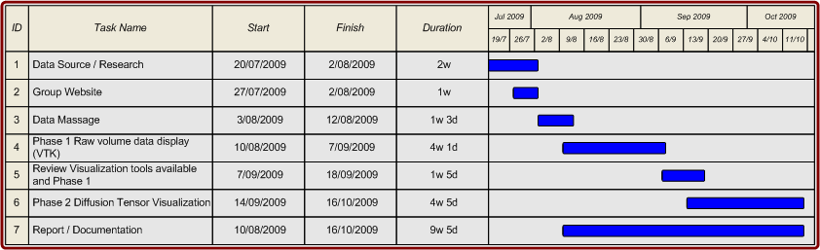**

* 1. **Progress to date**
* Diffuse Tensor MRI data gathered from 2005, 2009 IEEE Visualization Contests.
* Background research into Tensor Visualization, Tensor Glyphs, Fiber Tracking and Hyperstreamlines. (Reference to book from Joe)
* Google code used for group repository, allowing source control and general project related communication via our “brainvisualization” site.
* Data extracted from binary files into matlab ready for reformatting.
  1. **Risks**
* Due to in-experience with particular visualization toolkits there is the risk that after completion of Phase 1 we change our visualization toolkit and need to port to another.
  1. **Journal**

**Appendix: References**

**Kondratieva, P., Kruger, J., Westermann, R. The Application of GPU Particle Tracing to Diffusion Tensor Field Visualization, Computer Graphics and Visualization Group, Technische Universit at Munchen**

Data sources: P. Kondratieva, J. Krüger, R. Westermann, IEEE Visualisation 2005 Contest

[1] "Diffusion MRI" W*ikipedia*. [Online]. Available: http://en.wikipedia.org/wiki/Diffusion\_MRI. [Accessed: August, 20, 2009].